Project Portfolio

n9179437 | Team 43

IFB299

Laura Buckley

2016

Artefacts

# Release 1

## Artefact 1 –Website Mock-ups and Logo

Description:   
When creating the aesthetic and concept we wanted to pursue for our web application we created several mock-ups and concepts to present to our client team. I was responsible for designing a formal mock-up based on the suggestions of my team members for the application. Furthermore, I also designed the Logo for the web application.

### Importance:

Though this design was not used in the final implementation it provided a good starting point for both our design and client team to properly understand and visualize the requirements of the project.

### Why I did this:

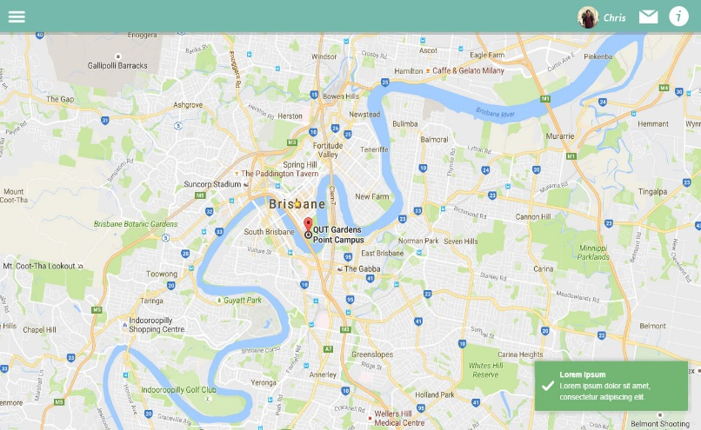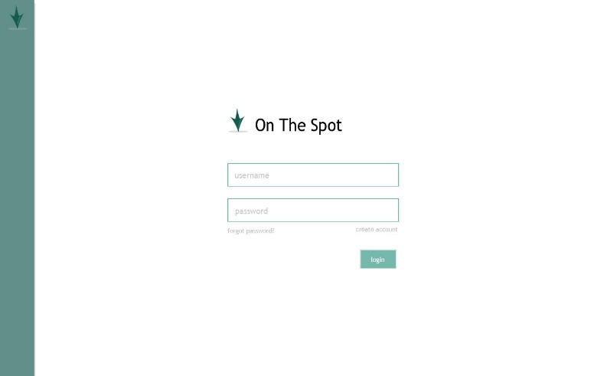I was responsible for doing this as I have a creative industries background, allowing me to quickly create professional mock-ups and designs.

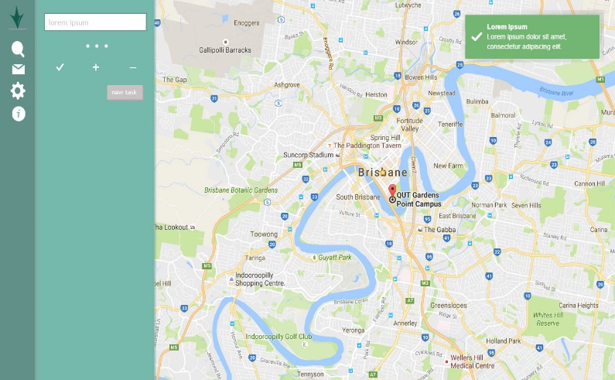



## Artefact 2 - Peer Review Letter

Description:   
After our client’s team presentation we were required as a team to provide feedback through a peer review letter. After taking the input from my team members, Mathew and I compiled the feedback into a concise business letter.

### Importance:

This task was important as it was an assessment piece as well as crucial for providing feedback to our client group. The business letter allowed my group to share our views and opinions on the current state of the client’s team development.

### Why I did this:

I was placed in charge of the peer review as an extension of my responsibility of maintaining communication between my team and out client group. Furthermore, as I am currently undergoing a duel degree in Creative Industries as well as IT I possessed additional skills that aided me in writing a formal business letter.

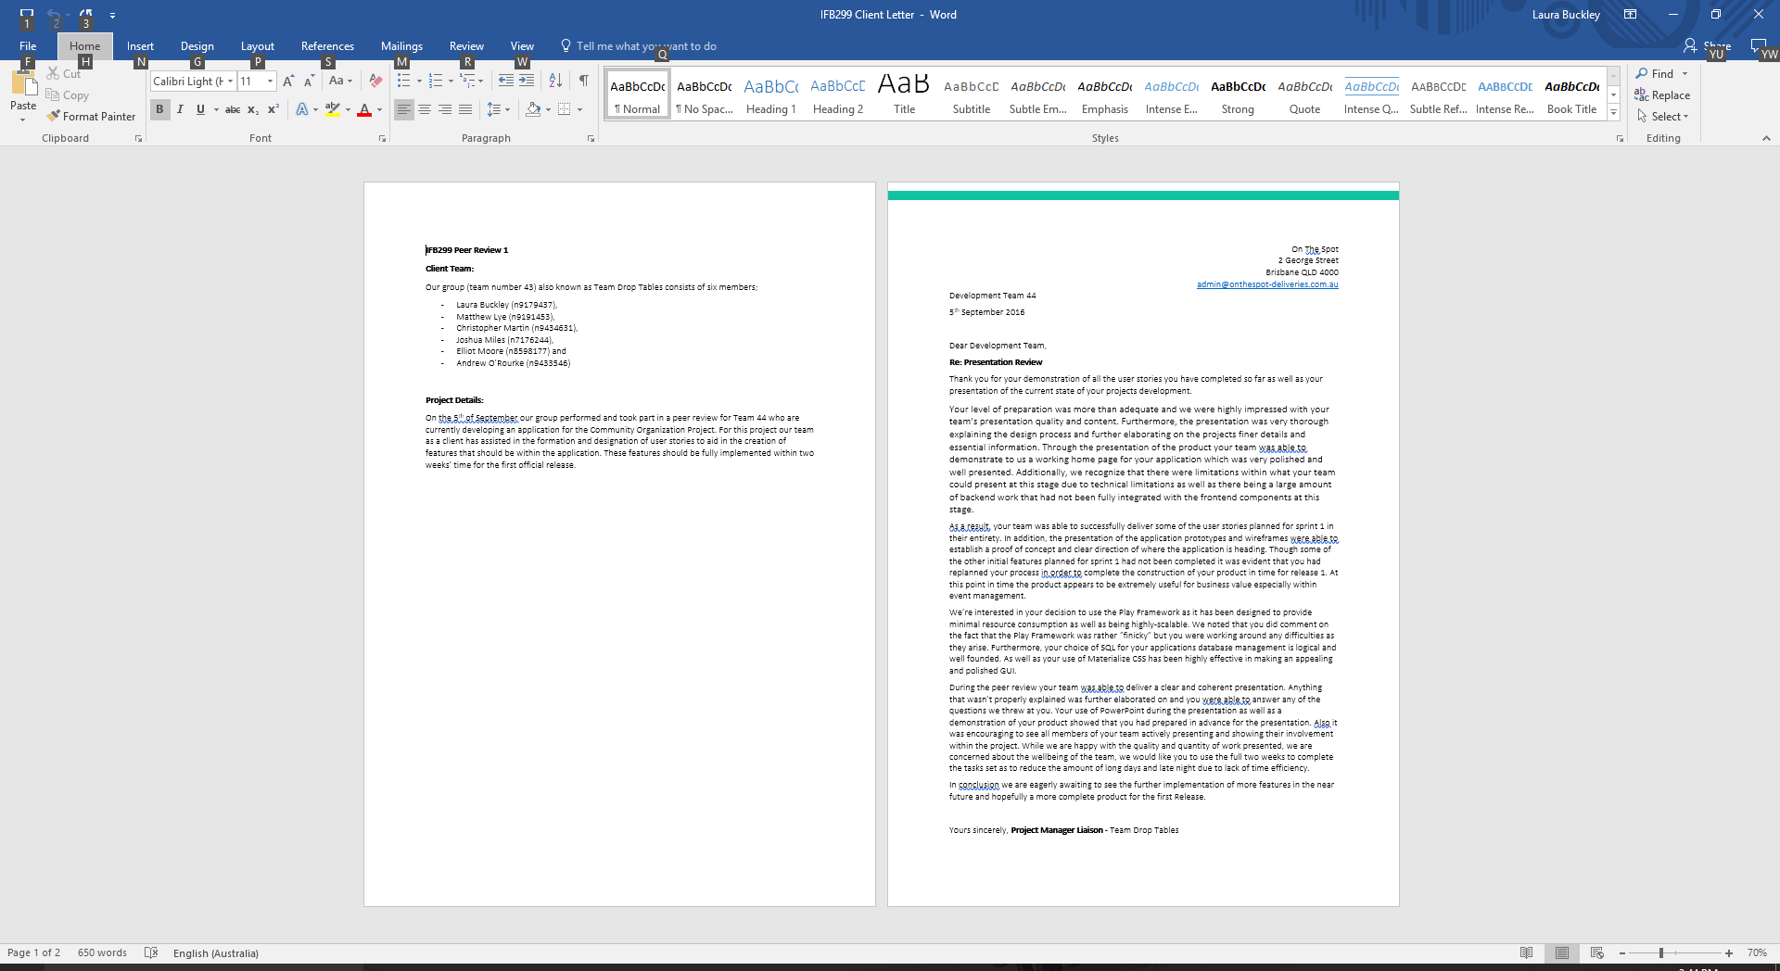

## Artefact 3 - Agile Testing Script

Description:   
I created an agile test script to test the functionality of the website. This script contained tests specifically regarding the user stories and their functionality.

### Importance:

The agile test script was used to test how a user would interreact with the application and to confirm that the product was meeting all the requirements of the user stories.

### Why I did this:

I oversaw the creation and implementation of testing throughout the projects development. I undertook this task as I have a background in computer science allowing me to understand the process used for the application and provide feedback on potential fixes and alterations that could be implemented. Furthermore, I was not directly involved with the creation of the back-end side of the application, this was beneficial for testing as I created cases based on the clients and projects specifications rather than from a preconceived notion of how it

should be functioning.

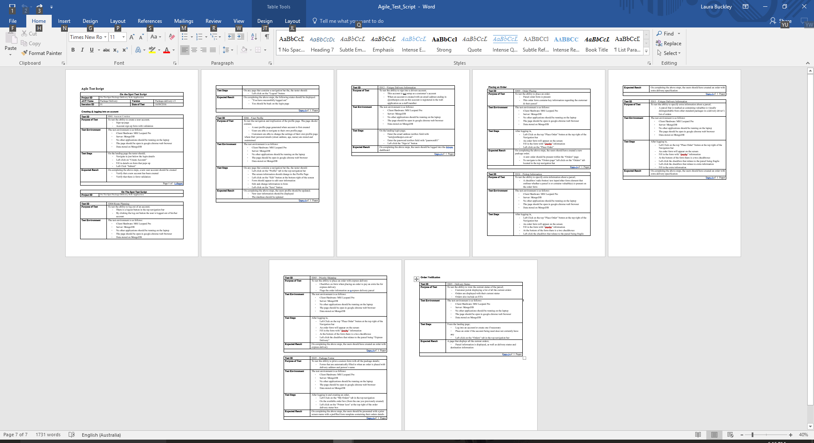

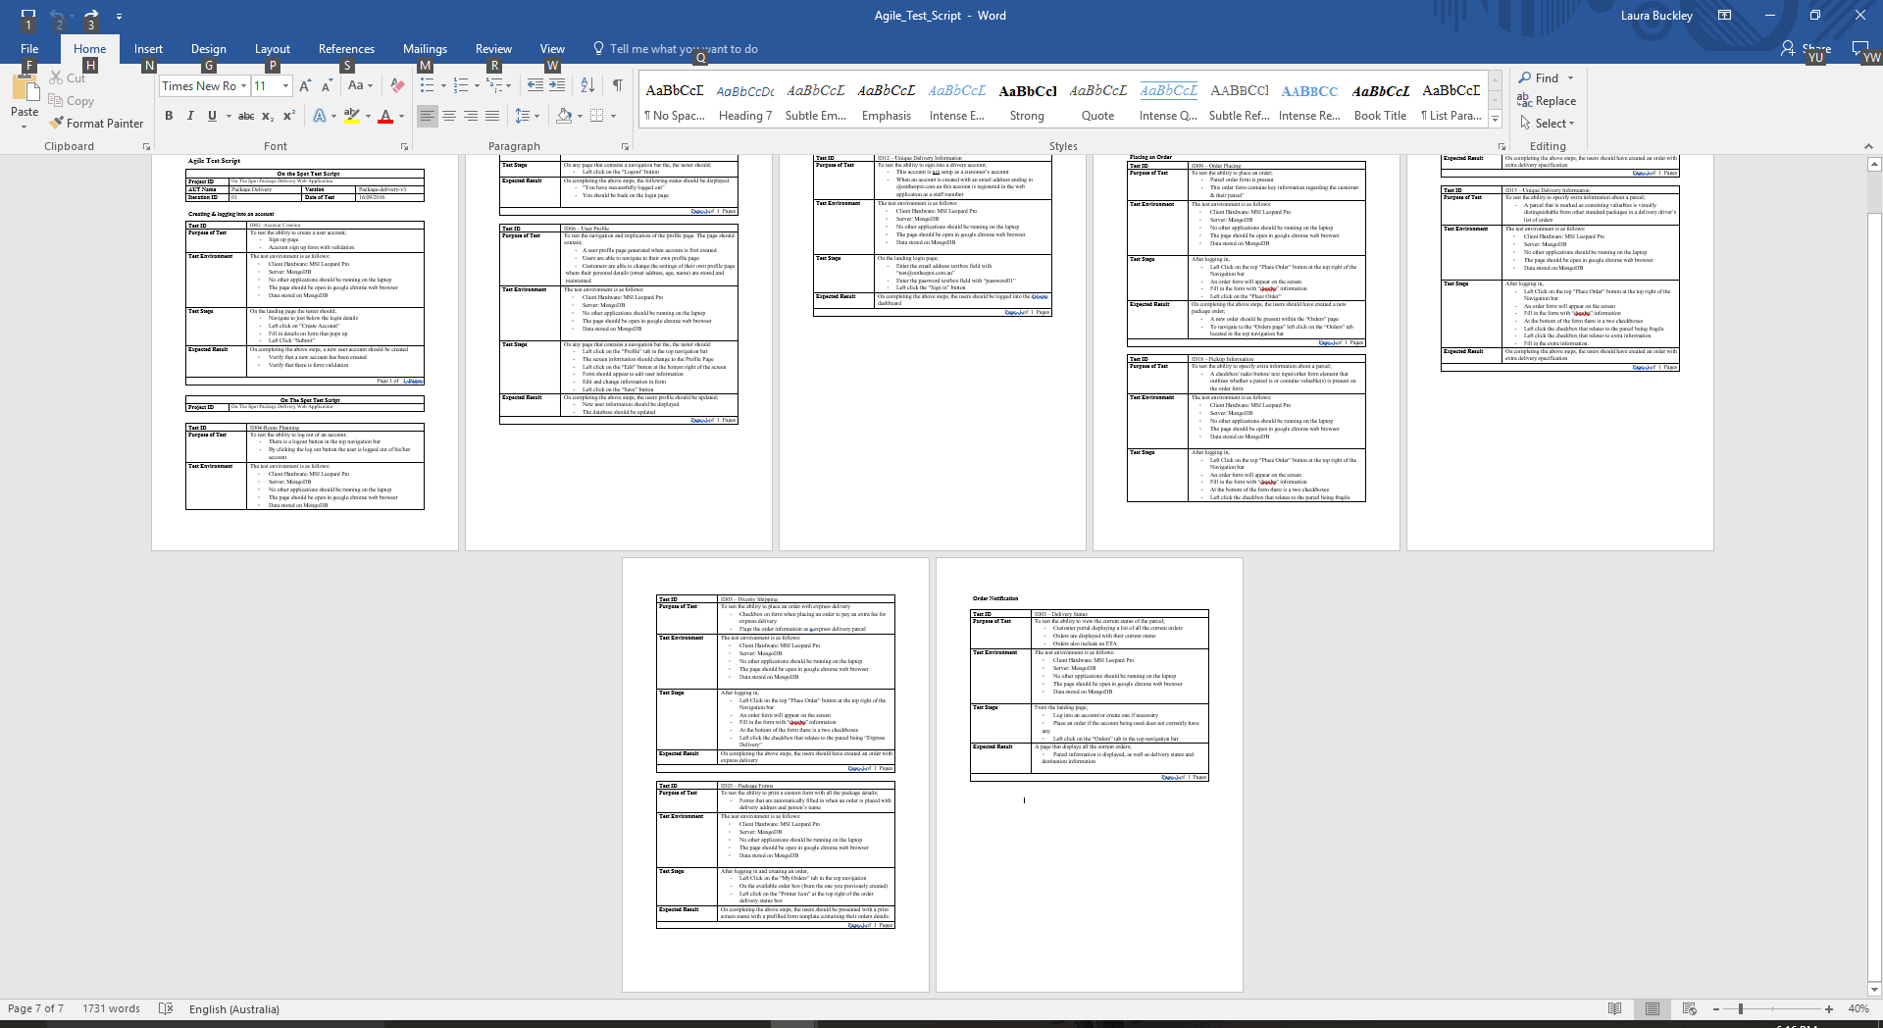

## Artefact 4 - User Page CSS and HTML

Description:   
One of the pages on our application was the profile page, that would contain information about the user that they could update and edit.

### Importance:

This was one of the user stories specified by our client team, thus making it important in regards to the acceptance criteria of the first release.

### Why I did this:

I have some experience with CSS and HTML, so like many of my team mates I volunteered to do one of the front-end pages that was required for our first release.

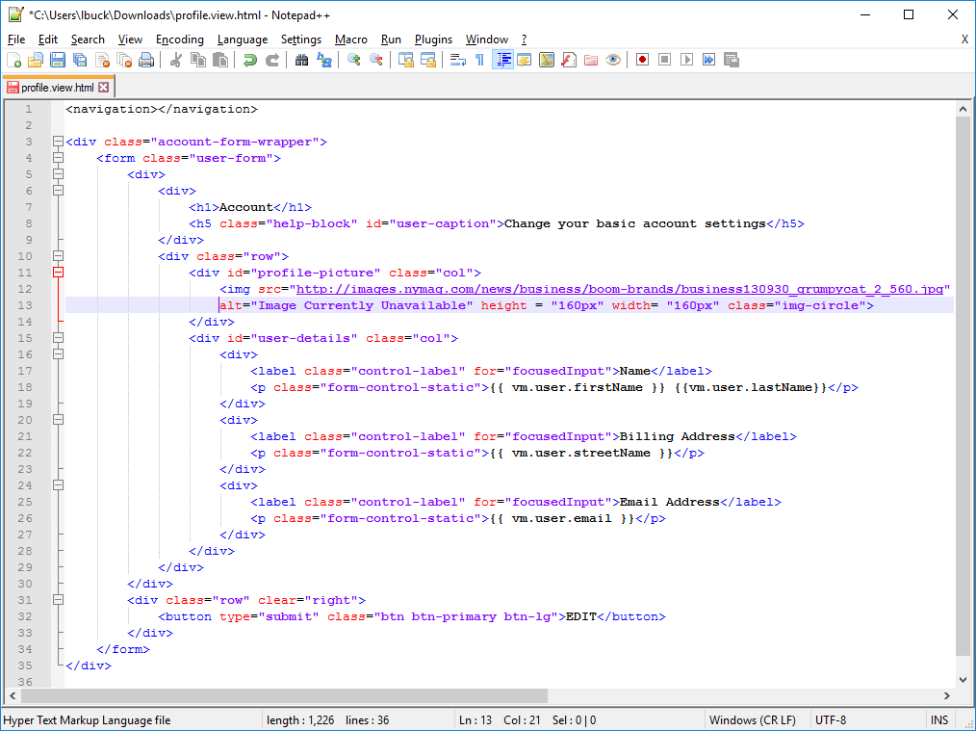

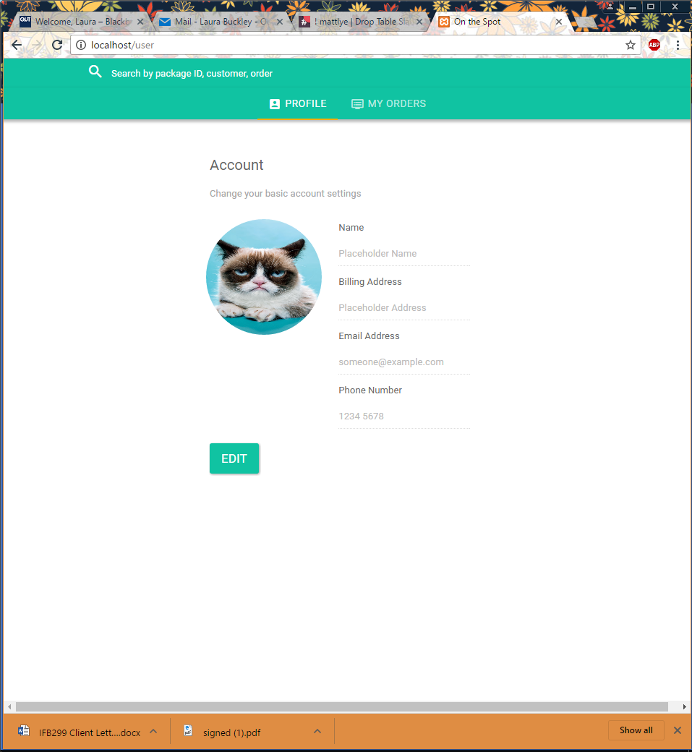

## Artefact 5 – Team Agreement

Description:   
The Team Agreement was a set of rules and guidelines that my team were to follow throughout the duration of the project to perform to the best of our abilities.

### Importance:

The Team Agreement outlined how we were going to approach the project as well as how we would deal with certain situations. It was to be used in a time of conflict to resolve certain situations as well as provide agreed upon terms for how we would conduct ourselves.

### Why I did this:

As the Scrum Master, I took the initiative to write up an agreement for my team. For this agreement, I outlined a combination of terms from both myself and my team that we would abide by throughout the project. I felt I should do this as the leader to ensure that everyone could be held accountable as well as ensuring everyone knew the expectations of each other going into the project.

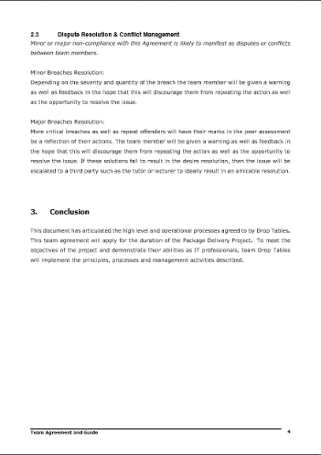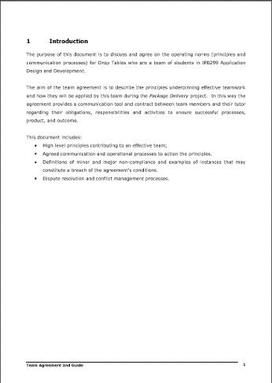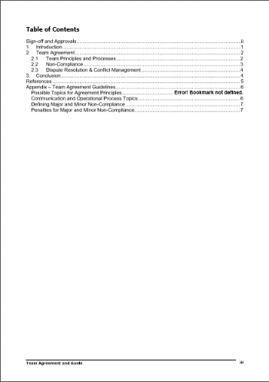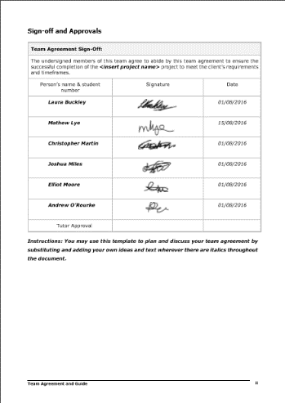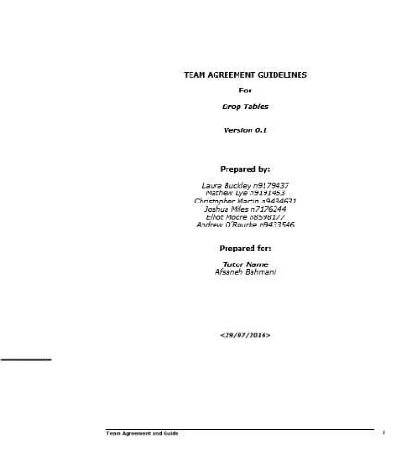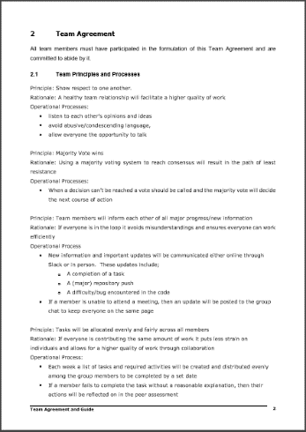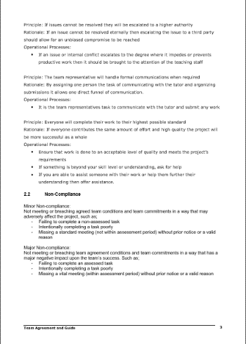

# Release 2

## Artefact 1 - Peer Review Letter

Description:   
After our client’s team presentation we were required as a team to provide feedback through a peer review letter. After taking the input from my team members, Mathew and I compiled the feedback into a concise business letter regarding the development team’s second release.

### Importance:

This task was important as it was an assessment piece as well as crucial for providing feedback to our client group. The business letter allowed my group to share our views and opinions on the current state of the client’s team development.

### Why I did this:

As stated previously I was placed in charge of the peer review as one of my communication responsibilities between my team and our client group.

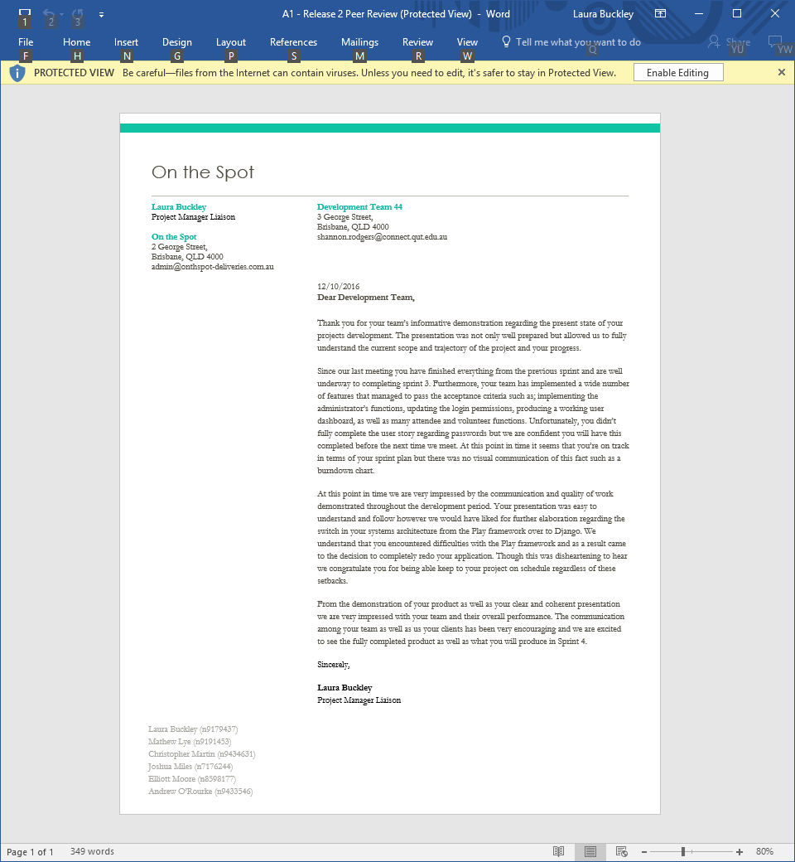

## Artefact 2 - Agile Testing Script

Description:   
I created an agile test script to test the functionality of the website. This script contained tests specifically regarding the user stories and their functionality.

### Importance:

The agile test script was used to test how a user would interreact with the application and to confirm that the product was meeting all the requirements of the user stories.

### Why I did this:

I oversaw the creation and implementation of testing throughout the projects development. I undertook this task as I have a background in computer science allowing me to understand the process used for the application and provide feedback on potential fixes and alterations that could be implemented.

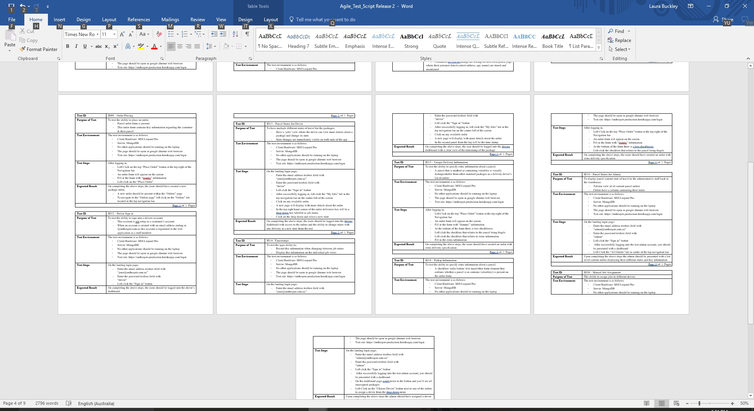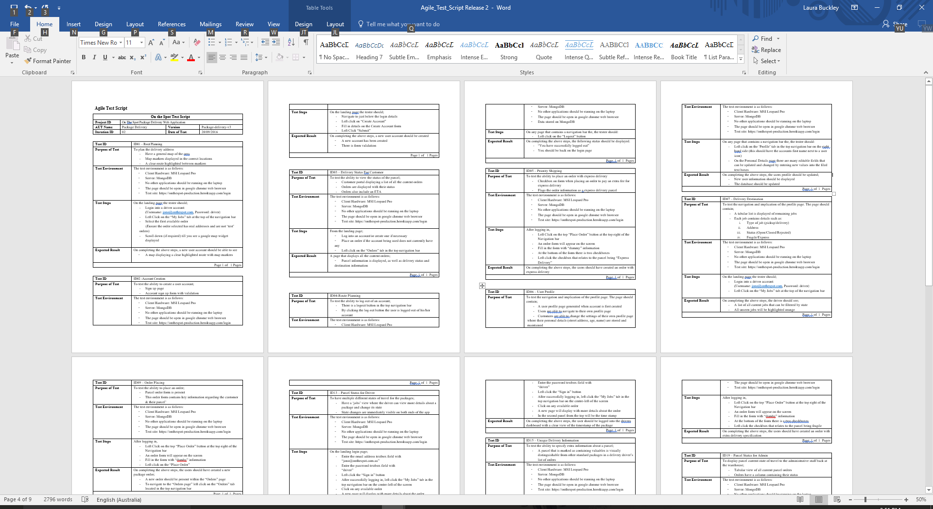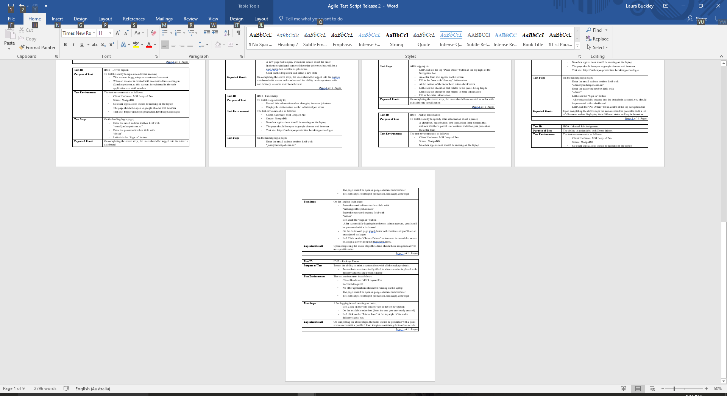

## Azrtefact 3 - Selenium Tests

Description:   
The Selenium IDE is an integrated development environment for Selenium scripts. This environment allowed us to record, edit and debug tests to ascertain that our application was working correctly.

### Importance:

The Selenium tests were used to check the application with automated test cases to prove that the product was functioning properly. These tests ensured everything was functioning properly and was good for discovering bugs while also checking everything was logging correctly.

### Why I did this:

As mentioned with the Agile Testing Script I undertook this task as I have a background knowledge allowing me to provide feedback on potential fixes and alterations that could be implemented. As I was not directly involved with the creation of the back-end side of the application, this was beneficial for testing as I created cases based on the clients and projects specifications rather than from a preconceived notion of how it

should be functioning.

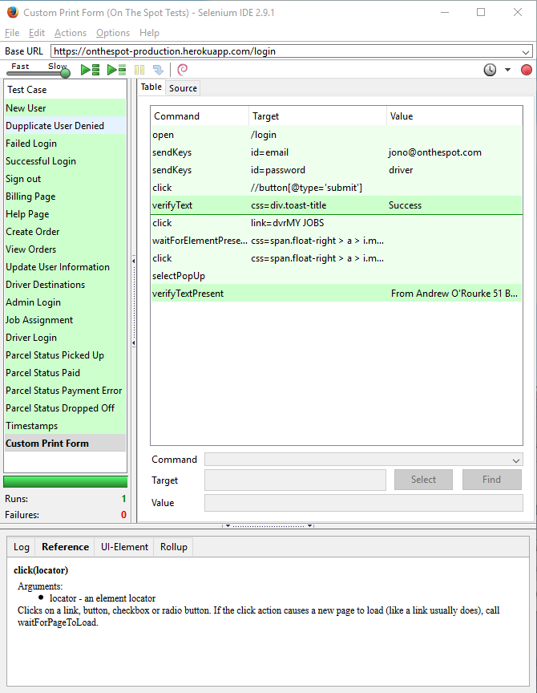

## Artefact 4 - User Testing

Description:   
A week after our Release 1 demonstration we decided to hold a small testing session where we organised people to quickly test our application and fill out a form regarding their opinions. We also ran another test session before we presented our Release 2 demonstration to try and determine if we had managed to successfully improve upon our product.

### Importance:

This was important to the project as it lead to us redesigning pages and features as well as streamlining certain processes. We were able to combine the user feedback with that of the tutors and client team’s comments to revamp certain elements. The first user testing session resulted in a complete redesign of the pages because they were just missing the mark on what they needed to be.

### Why I did this:

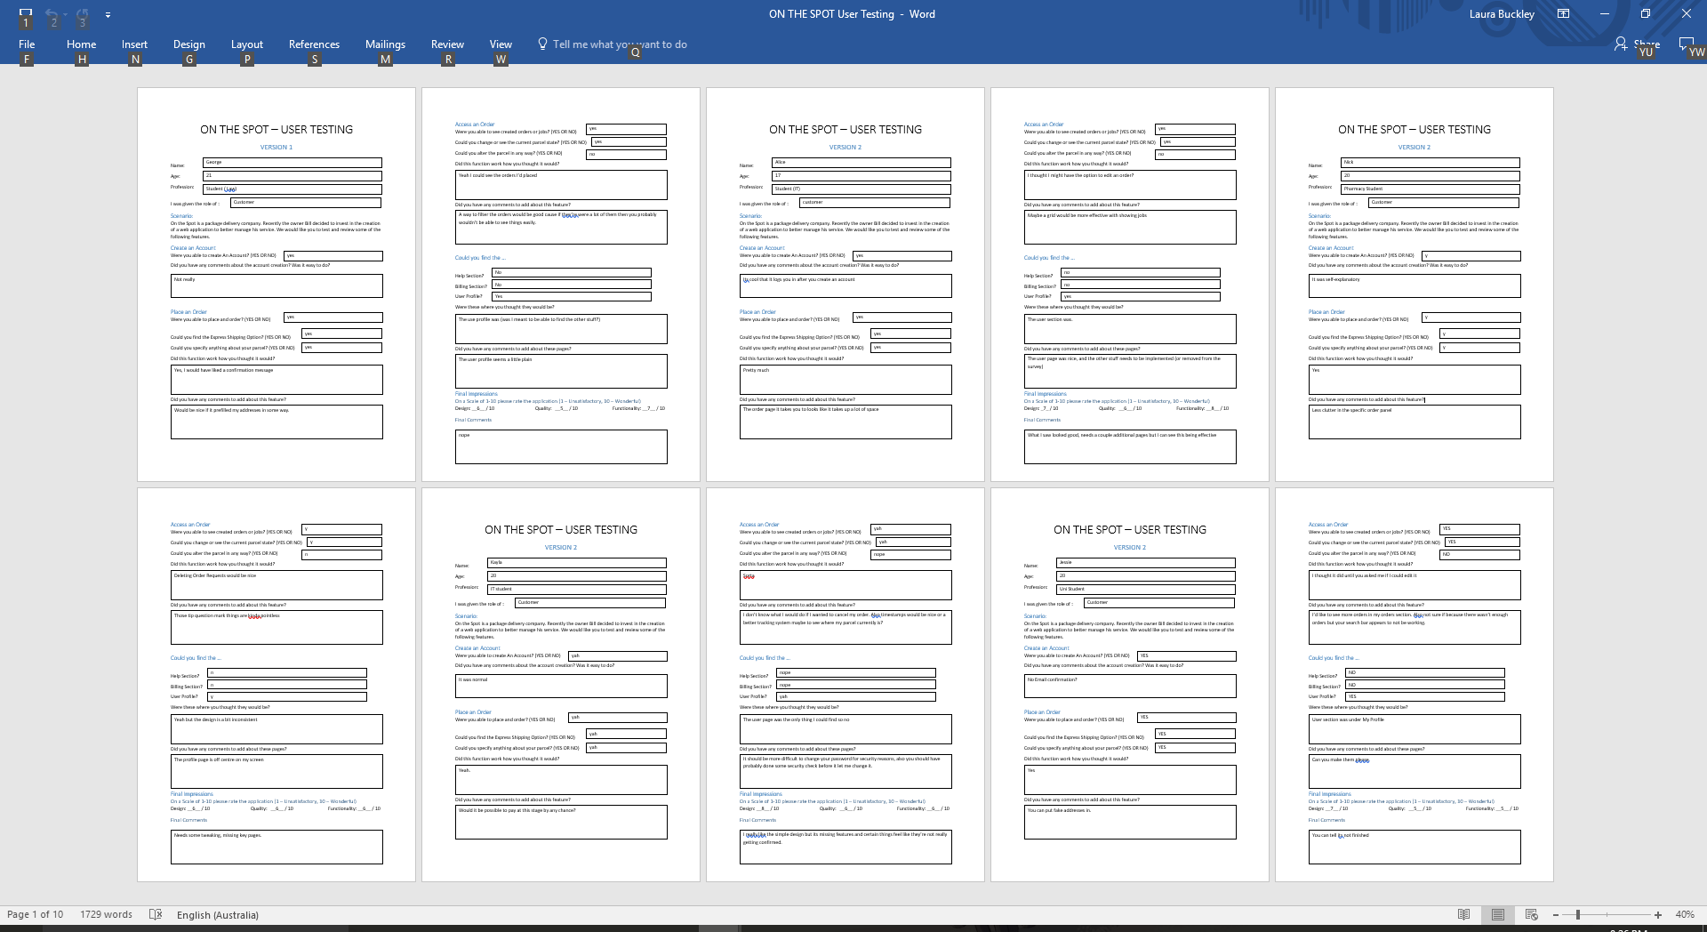I organized this session to get my team to better understand a user’s needs and to also further our understanding on what our application was missing and needed improve to make it more user friendly.

## Artefact 5 - Sprint Planning/Release Document

Description:   
The sprint plan was used throughout our projects lifespan to prioritize tasks and to ensure that we were delivering the most necessary functions for our product. Sprint planning is an important part of the SCRUM development environment, and was crucial to the planning of out project.

### Importance:

Throughout the course of the project my team and I constructed sprint plans to determine what we needed to deliver and prioritize the more essential tasks. By doing this we could maintain a consistent schedule and remain both focused and organized.

### Why I did this:

Sprint planning helped keep my team focused and on track for the duration of the project. We could prioritize certain features and user stories over others based on the story points. And as the project progressed it was very informative in enabling us to gauge how long things would take us to complete. Because of our sprint plan we could make a functioning app with only a few minor features missing.